Step 1: Launching Server for GitHub and Connecting to GitBash

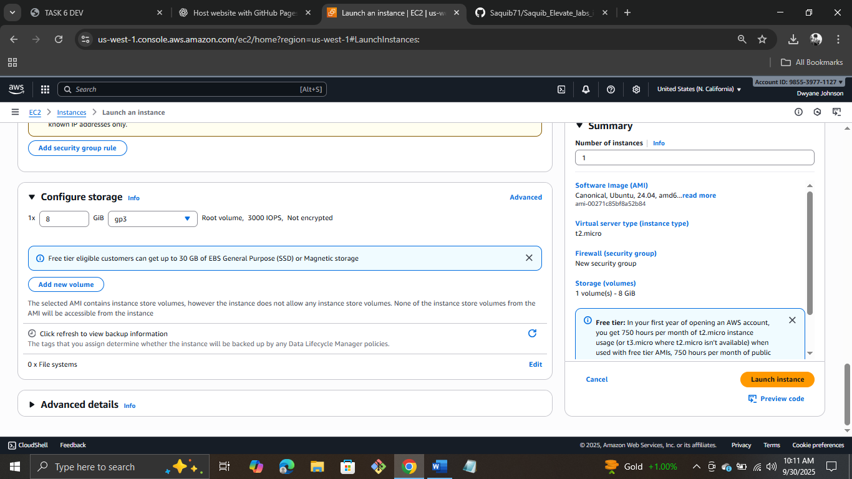

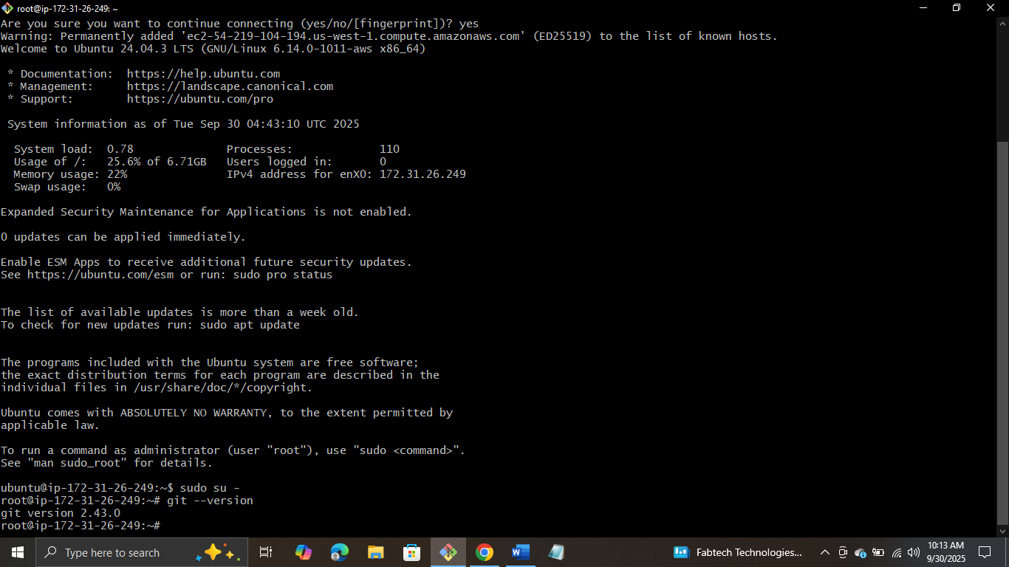

Step 2: Creating a folder and creating Index.html file

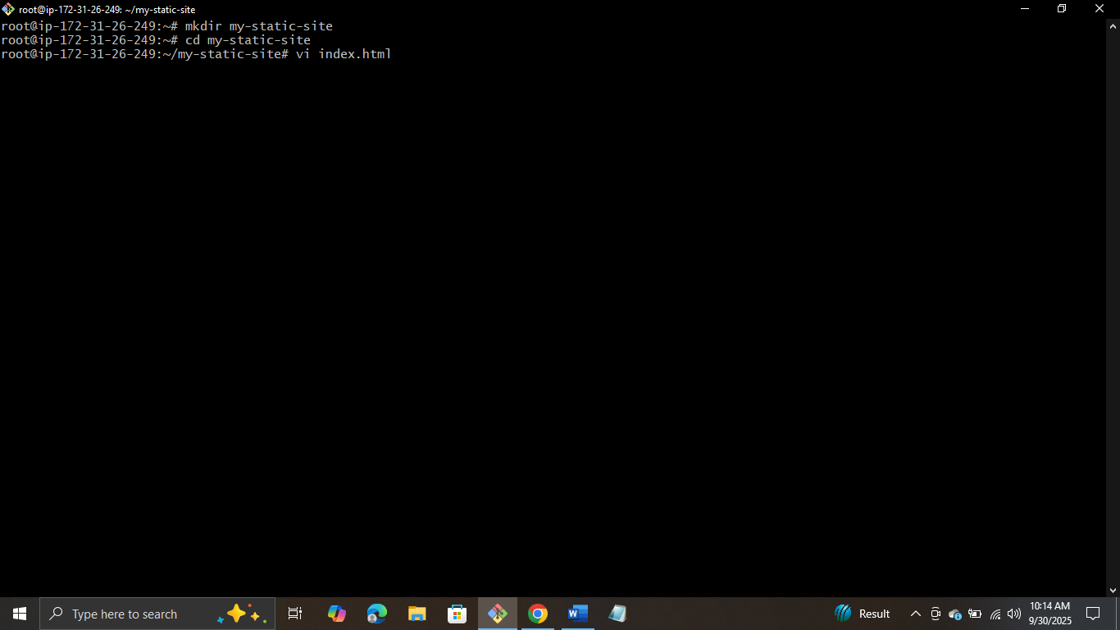

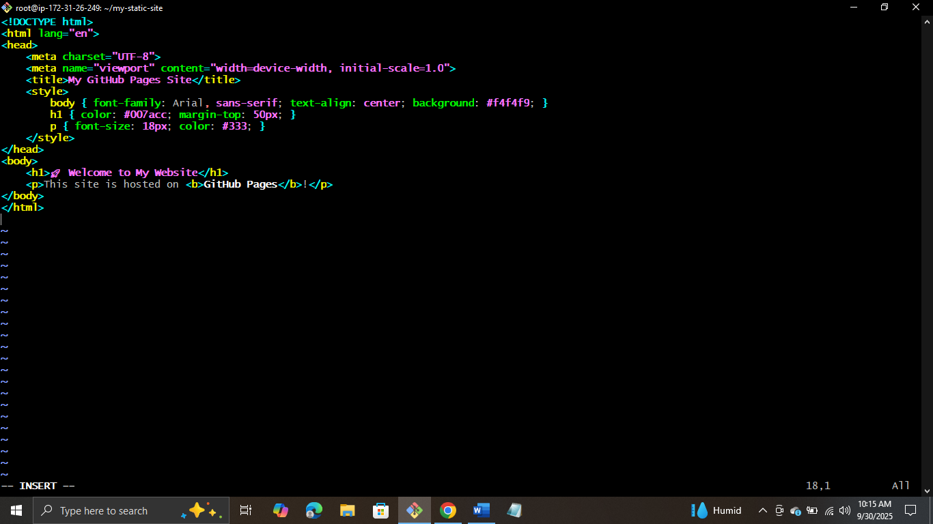

Step 3: Initializing Git and adding credentials

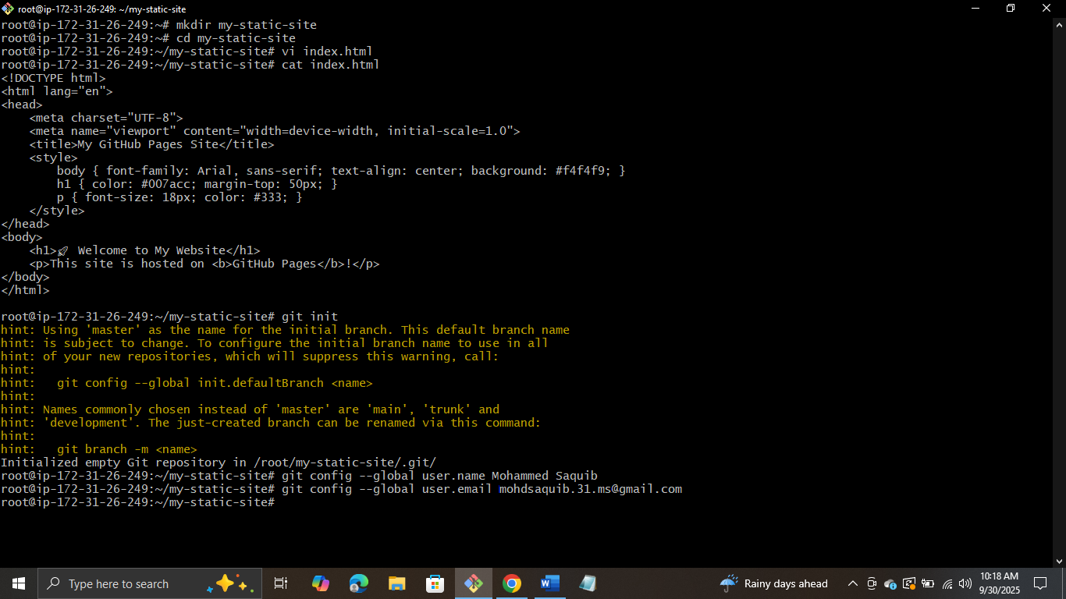

Step 4: Creating new Rep and adding it

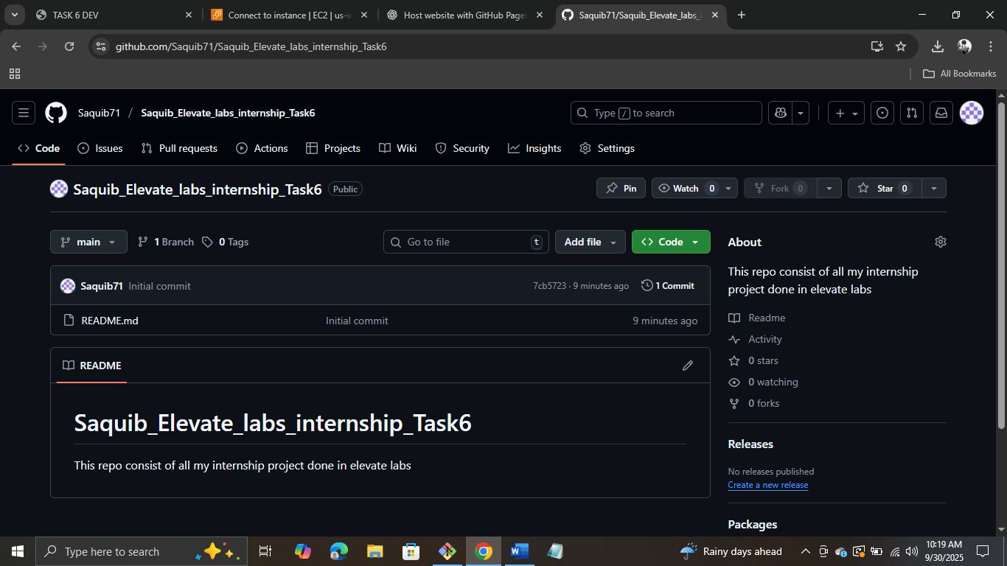

Step 5: Adding the changes and committing it

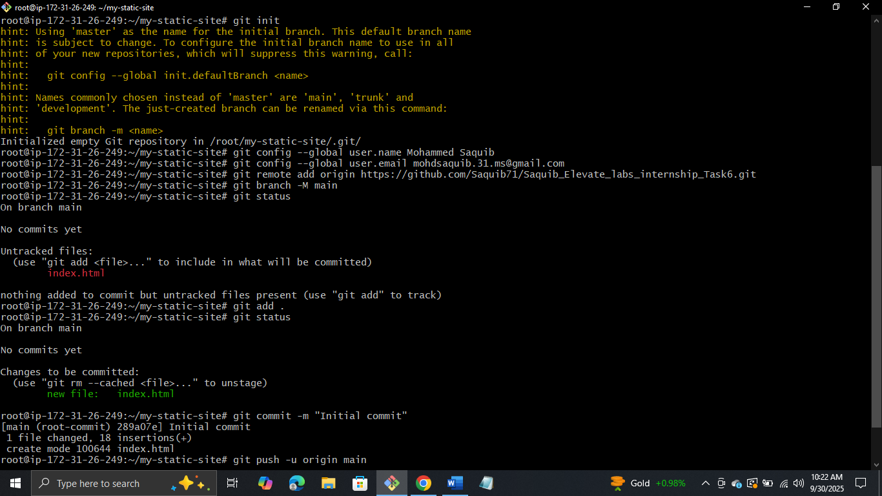

Step 6: Pushing website to GitHub

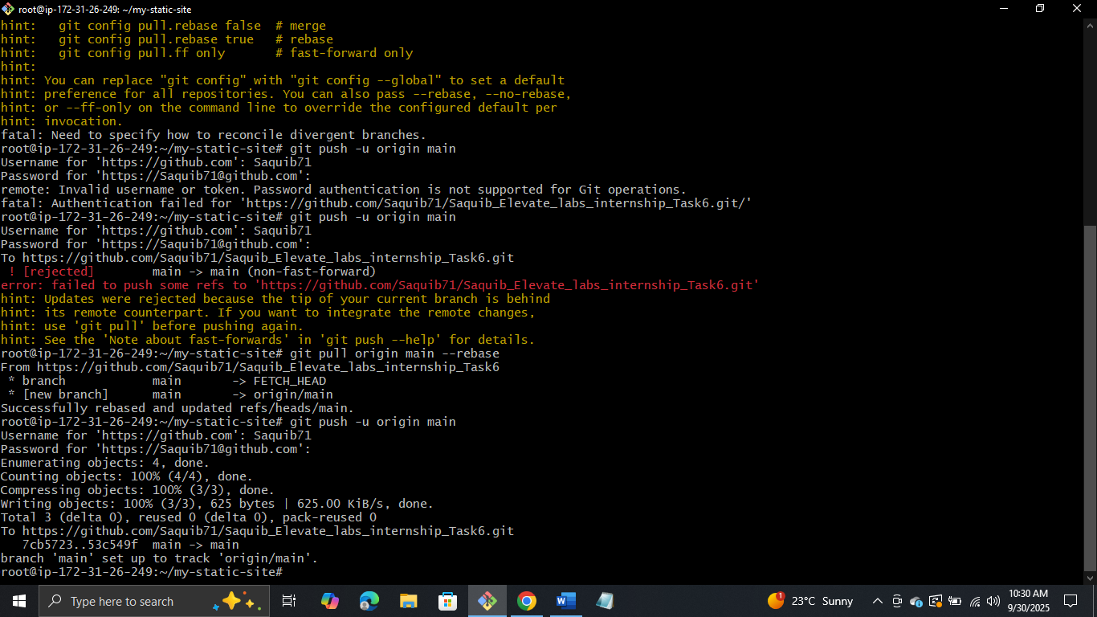

Step 7: Enable GitHub Pages

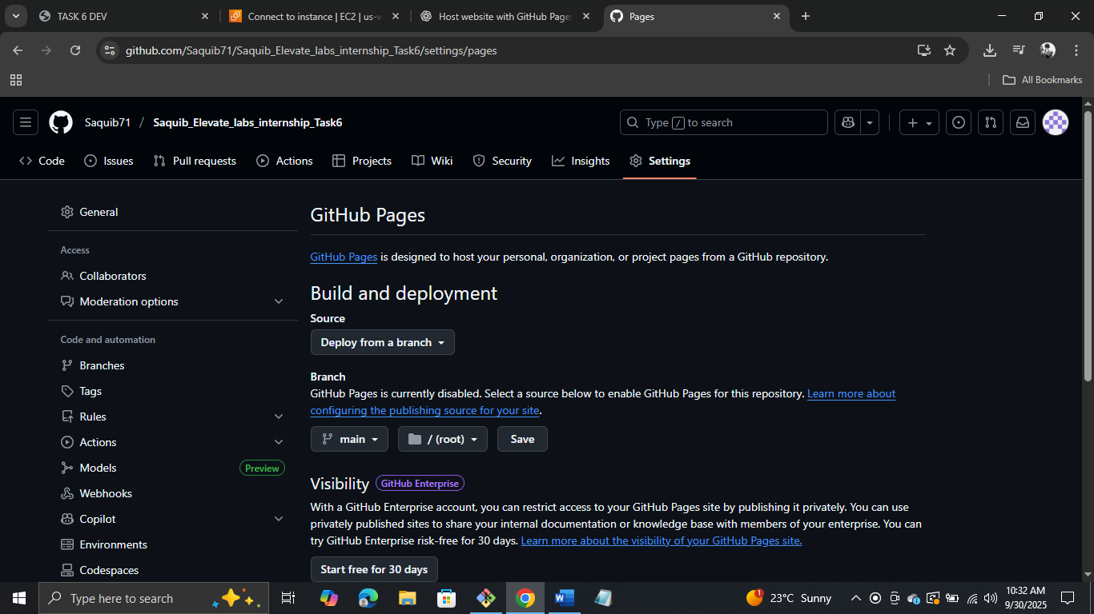

Step 8: Link got generated

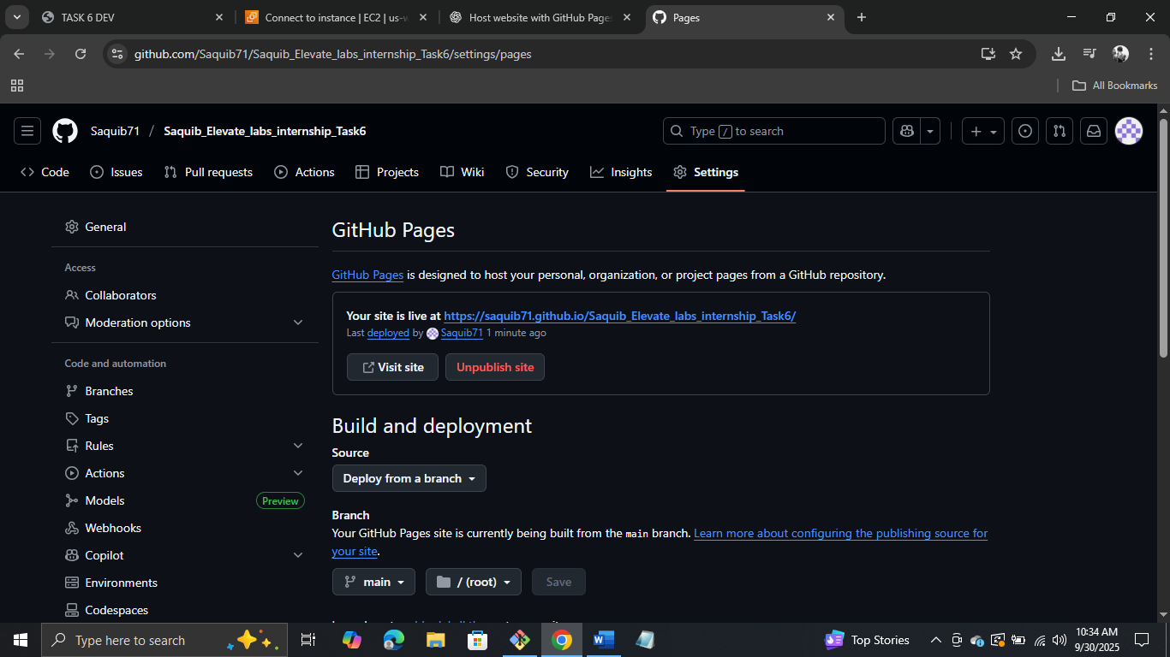

Step 9: Accessing it n Browser

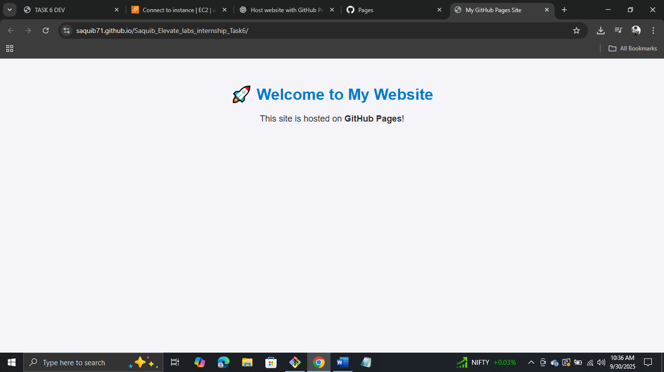

Step 10: Creating CSS file and linking it with Index.html file

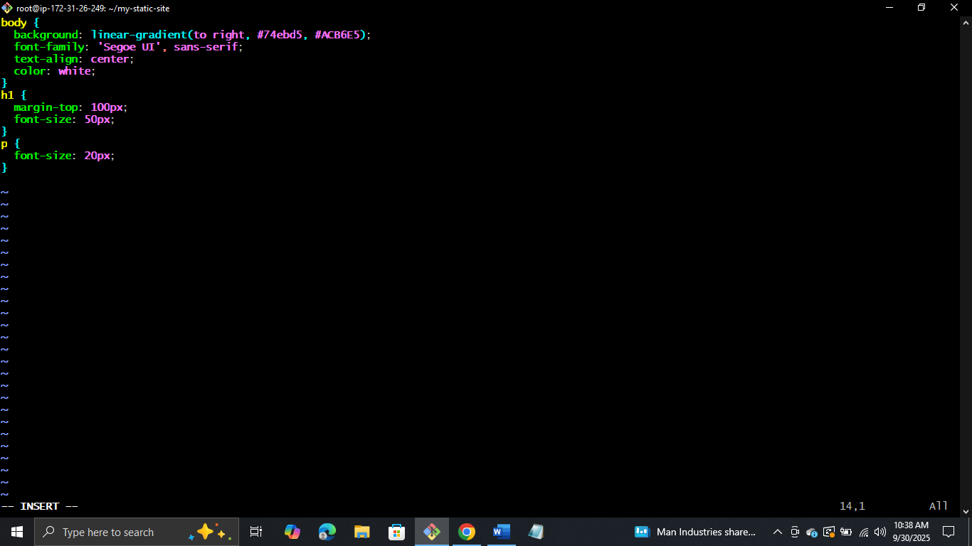

Step 11: Adding and committing and pushing the changes to GitHub

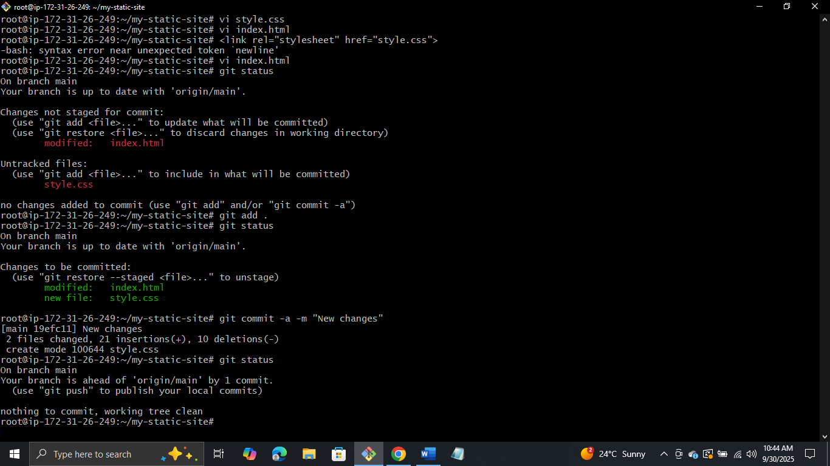

Step 12: Verifying

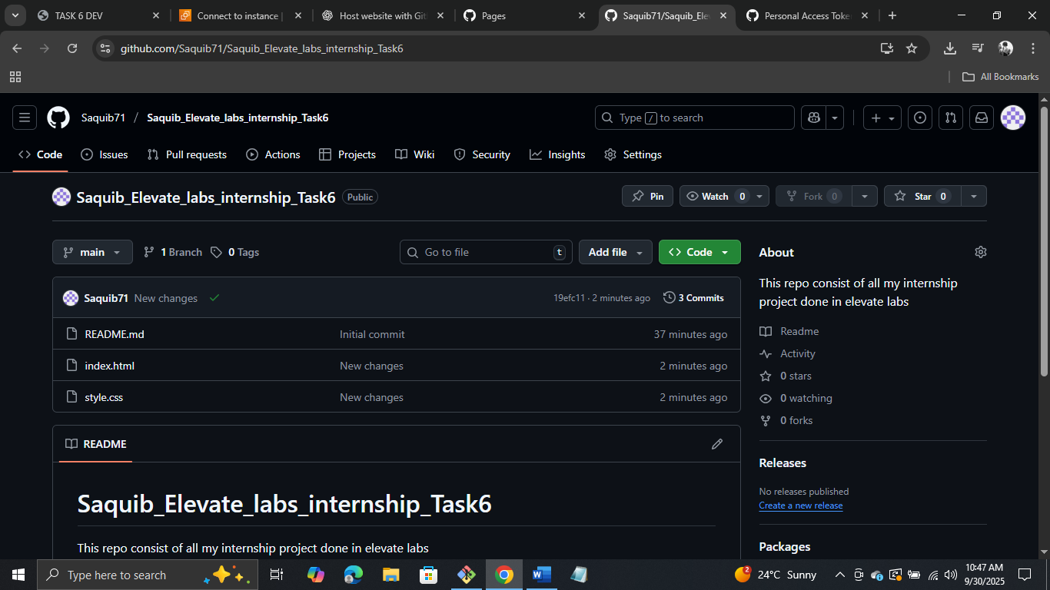

Step 13: Refreshing and seeing

